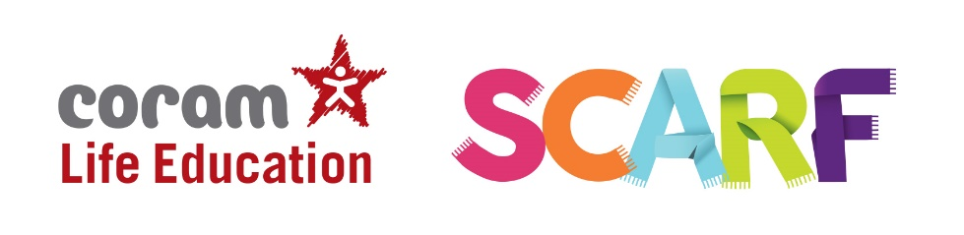
Common questions asked about RSE
Is Relationships and Sex Education (RSE) compulsory?
It’s compulsory for primary schools to teach Relationships Education and Health Education.
The Department for Education (DfE) also strongly encourage schools to teach Sex Education. Schools must consult parents in developing and reviewing their RSE policy. Schools should ensure that the policy meets the needs of pupils and parents and reflects the community they serve.
Schools should also ensure that, when they consult with parents, they provide examples of the resources that they plan to use. This can provide reassurance for parents and helps to continue the conversations started in class at home.
Where a primary school chooses to teach aspects of sex education (which go beyond the statutory National Curriculum for Science requirements), the school must set this out in their policy and all schools should consult with parents on what is to be covered. Primary schools that choose to teach non–statutory sex education must allow parents a right to withdraw their children.

Does SCARF cover non-statutory Sex Education?
There is very little in the SCARF programme that is non-statutory. We interpret sex education to mean puberty, conception, reproduction and birth. All of these themes, with the exception of conception, are statutory and included in either Health Education or National Curriculum Science.
The statutory guidance states that sex education should ensure children know how a baby is conceived. We interpret 'how a baby is conceived' as referring to what happens during sexual intercourse before an egg and sperm meet (reproduction). We therefore include sexual intercourse as well as IVF in our Year 6 Making Babies lesson. For further information see our FAQ’s on our website.
We’ve also been asked whether teaching about HIV at Primary level is statutory. HIV is included in the SCARF programme as it helps schools to meet their statutory requirements under Health Education (in the Health and Prevention category) for all children by the end of year 6 to know:
- About personal hygiene and germs including bacteria, viruses, how they are spread and treated, and the importance of hand washing.

SCARF is a spiral curriculum and so previous lessons would have covered hygiene, bacteria and the importance of hand washing, this naturally leads on to discussions about different viruses, of which HIV is important to understand.
The purpose of this particular SCARF lesson is to raise awareness and reduce stigma and misconceptions surrounding HIV. This follows the guidance of the Sex Education Forum, of which we are members (see curriculum design tool).
Although talking about viruses is statutory, talking about HIV, specifically at primary level, is not. Your school will have made a decision as to whether there is any reason not to teach it at Year 6.
Schools are best-placed to assess their pupils’ needs and SCARF is flexible, so teachers can adapt content to meet these needs. They will consider whether the children have already mentioned it, whether they referring to HIV either appropriately or inappropriately, and whether they have a good understanding of how it can and can't be passed on. An understanding of these issues will help them explain the reasons for including this SCARF lesson – or not – in order to meet pupils’ needs.
The statutory guidance aims to provide a balance between what must be taught by the end of Year 6, alongside decisions about how and when the school delivers the content. Parent consultation helps each school to strike a balance that’s appropriate to the needs of its children.

When will my child’s school be delivering Relationships and Sex Education?
If your child’s school has already consulted parents regarding their RSE policy and shared sample resources with you, then they could start delivering it from September 2020. If not, they have until the beginning of the summer term 2021 to consult parents before they start delivering RSE. The school should ensure they communicate with parents what they will be covering and when.

What can I do to support my child’s learning at home?
The statutory guidance is clear in recognising that a parent/carer is a child’s primary educator in these matters. There are a many things you can do to support your child’s understanding and encourage them to ask questions. Here are some
- If you feel it is time to talk to your child about growing up and the changes they are likely to experience it’s best to offer it in small chunks, rather than do it in one go, often known as ‘The Talk’. This gives children time to digest the new information and ask you further questions as they develop more understanding.
- If your child asks you questions try to stay calm, and not worry if you don’t know the answer. There are plenty of websites that you can use together to help you find the answers to their questions in a factual, honest, age appropriate way (see details below for resources on our website).
- Use everyday opportunities to bring up the topic; things you see on TV or hear on the radio can be great conversation starters to talk about topics such as relationships, sex and body image. Reading books with your child is also a great way of introducing topics and helping children to understand themselves, their bodies and the world around them.
- If you do have family names for genitals, ensure your child also knows their scientific names too. Nobody likes to think their child is at risk of abuse, but knowing the correct words for their genitals will help them report abuse if it did ever happen.
- By showing your child that you are comfortable with them asking you questions now, you are helping to develop a relationship with them where they can seek your advice and support in their adolescent years.
- Visit the specially created Coram Life Education SCARF webpage for more information including a list of books and websites that will support both you and your child along with some activities you to support their learning.

