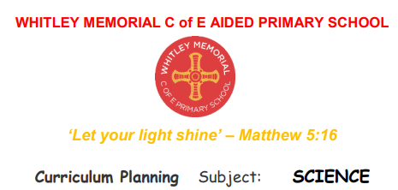

Progression in Working Scientifically Skills.
This document uses statements National Curriculum and PLAN assessment documents for Key Stage 1 and 2.
In EYFS the children are using the Characteristics of effective learning, which are the building blocks to the Working Scientifically Skills in KS1 and above. They will use skills through play and adult led activities that develop skills in showing curiosity and asking questions, making observations using their senses and simple equipment They will make direct comparisons, use equipment to measure, record their observations by drawing, taking photographs, using sorting rings or boxes and, in Reception, on simple tick sheet. They use their observations to help them to answer their questions, talk about what they are doing and have found out and identify, sort and group.
NB - The National Curriculum statements in italics in these tables indicate that they feature more than once.
At the Whitley we use the Primary Science Teaching Trust Symbols for Working Scientifically Skills and Enquiry Approaches to make it explicit to children how they are learning:
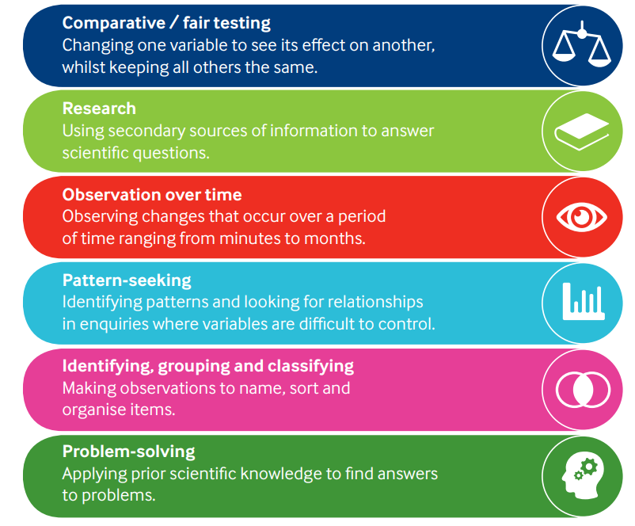
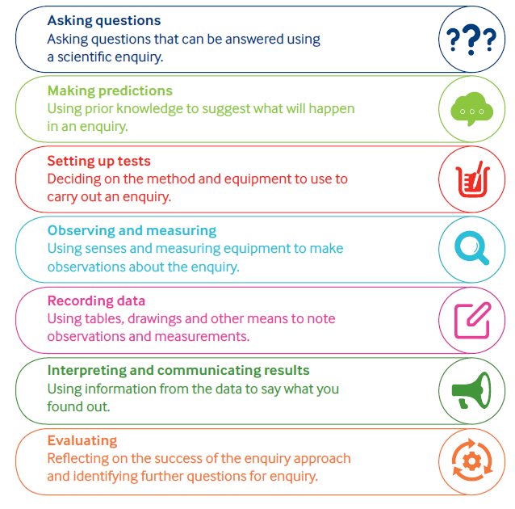

Asking Questions and recognising that they can be answered in different ways.
ng questions and recognising that they can be answered in different ways
Year 1 and 2 | Year 3 and 4 | Year 5 and 6
Asking simple questions and recognising that they can be answered in different ways:  • While exploring the world, the children develop their ability to ask questions (such as what something is, how things are similar and different, the ways things work, which alternative is better, how things change and how they happen). Where appropriate, they answer these questions.  • The children answer questions developed with the teacher often through a scenario.  • The children are involved in planning how to use resources provided to answer the questions using different types of enquiry, helping them to recognise that there are different ways in which questions can be answered. | Asking relevant questions and using different types of scientific enquiries to answer them:  • The children consider their prior knowledge when asking questions. They independently use a range of question stems. Where appropriate, they answer these questions.  • The children answer questions posed by the teacher.  • Given a range of resources, the children decide for themselves how to gather evidence to answer the question. They recognise when secondary sources can be used to answer questions that cannot be answered through practical work. They identify the type of enquiry that they have chosen to answer their question. | Planning different types of scientific enquiries to answer questions, including recognising and controlling variables where necessary:  • Children independently ask scientific questions. This may be stimulated by a scientific experience or involve asking further questions based on their developed understanding following an enquiry.  • Given a wide range of resources the children decide for themselves how to gather evidence to answer a scientific question. They choose a type of enquiry to carry out and justify their choice. They recognise how secondary sources can be used to answer questions that cannot be answered through practical work.

Making observations and taking measurements
Year 1 and 2 | Year 3 and 4 | Year 5 and 6
Observing closely, using simple equipment  • Children explore the world around them. They make careful observations to support identification, comparison and noticing change. They use appropriate senses, aided by equipment such as magnifying glasses or digital microscopes, to make their observations.  • They begin to take measurements, initially by comparisons, then using non-standard units. | Making systematic and careful observations and, where appropriate, taking accurate measurements using standard units, using a range of equipment, including thermometers and data loggers:  • The children make systematic and careful observations.  • They use a range of equipment for measuring length, time, temperature and capacity. They use standard units for their measurements. | Taking measurements, using a range of scientific equipment, with increasing accuracy and precision, taking repeat readings when appropriate:  • The children select measuring equipment to give the most precise results e.g. ruler, tape measure or trundle wheel, force meter with a suitable scale.  • During an enquiry, they make decisions e.g. whether they need to: take repeat readings (fair testing); increase the sample size (pattern seeking); adjust the observation period and frequency (observing over time); or check further secondary sources (researching); in order to get accurate data (closer to the true value).

Engaging in practical enquiry to answer questions
Year 1 and 2 | Year 3 and 4 | Year 5 and 6
Performing simple tests:  • The children use practical resources provided to gather evidence to answer questions generated by themselves or the teacher. They carry out: tests to classify; comparative tests; pattern seeking enquiries; and make observations over time. Identifying and classifying  • Children use their observations and testing to compare objects, materials and living things.  They sort and group these things, identifying their own criteria for sorting.  • They use simple secondary sources (such as identification sheets) to name living things. They describe the characteristics they used to identify a living thing. | Setting up simple practical enquiries, comparative and fair tests:  • The children select from a range of practical resources to gather evidence to answer questions generated by themselves or the teacher.  • They follow their plan to carry out: observations and tests to classify; comparative and simple fair tests; observations over time; and pattern seeking.  Explanatory note:  A comparative test is performed by changing a variable that is qualitative e.g. the type of material, shape of the parachute. This leads to a ranked outcome.  A fair test is performed by changing a variable that is quantitative e.g. the thickness of the material or the area of the canopy. This leads to establishing a causative relationship. | Planning different types of scientific enquiries to answer questions, including recognising and controlling variables where necessary:  • The children select from a range of practical resources to gather evidence to answer their questions. They carry out fair tests, recognising and controlling variables. They decide what observations or measurements to make over time and for how long. They look for patterns and relationships using a suitable sample.

Recording and presenting evidence:
Year 1 and 2 | Year 3 and 4 | Year 5 and 6
Gathering and recording data to help in answering questions:  • The children record their observations e.g. using photographs, videos, drawings, labelled diagrams or in writing.  • They record their measurements e.g. using prepared tables, pictograms, tally charts and block graphs. • They classify using simple prepared tables and sorting rings. | Gathering, recording, classifying and presenting data in a variety of ways to help in answering questions.  Recording findings using simple scientific language, drawings, labelled diagrams, keys, bar charts, and tables:  • The children sometimes decide how to record and present evidence. They record their observation e.g. using photographs, videos, pictures, labelled diagrams or writing. They record their measurements e.g. using tables, tally charts and bar charts (given templates, if required, to which they can add headings). They record classifications e.g. using tables, Venn diagrams, Carroll diagrams.  • Children are supported to present the same data in different ways in order to help with answering the question. | Recording data and results of increasing complexity using scientific diagrams and labels, classification keys, tables, scatter graphs, bar and line graphs:  • The children decide how to record and present evidence. They record observations e.g. using annotated photographs, videos, labelled diagrams, observational drawings, labelled scientific diagrams or writing. They record measurements e.g. using tables, tally charts, bar charts, line graphs and scatter graphs. They record classifications e.g. using tables, Venn diagrams, Carroll diagrams and classification keys.  • Children present the same data in different ways in order to help with answering the question.

Answering questions and concluding
Year 1 and 2 | Year 3 and 4 | Year 5 and 6
Using their observations and ideas to suggest answers to questions:  • Children use their experiences of the world around them to suggest appropriate answers to questions. They are supported to relate these to their evidence e.g. observations they have made, measurements they have taken or information they have gained from secondary sources. | Using straightforward scientific evidence to answer questions or to support their findings:  • Children answer their own and others’ questions based on observations they have made, measurements they have taken or information they have gained from secondary sources. The answers are consistent with the evidence | Identifying scientific evidence that has been used to support or refute ideas or arguments:  • Children answer their own and others’ questions based on observations they have made, measurements they have taken or information they have gained from secondary sources. When doing this, they discuss whether other evidence e.g. from other groups, secondary sources and their scientific understanding, supports or refutes their answer.  • They talk about how their scientific ideas change due to new evidence that they have gathered.  • They talk about how new discoveries change scientific understanding.
Using their observations and ideas to suggest answers to questions:  • The children recognise ‘biggest and smallest’, ‘best and worst’ etc. from their data. | Identifying differences, similarities or changes related to simple scientific ideas and processes:  • Children interpret their data to generate simple comparative statements based on their evidence. They begin to identify naturally occurring patterns and causal relationships.  Using results to draw simple conclusions, make predictions for new values, suggest improvements and raise further questions:  • They draw conclusions based on their evidence and current subject knowledge. | Reporting and presenting findings from enquiries, including conclusions, causal relationships and explanations of and degree of trust in results, in oral and written forms such as displays and other presentations:  • In their conclusions, children: identify causal relationships and patterns in the natural world from their evidence; identify results that do not fit the overall pattern; and explain their findings using their subject knowledge.
Evaluating and raising further questions and predictions
Year 1 and 2 | Year 3 and 4 | Year 5 and 6
 | Using results to draw simple conclusions, make predictions for new values, suggest improvements and raise further questions:  • They identify ways in which they adapted their method as they progressed or how they would do it differently if they repeated the enquiry. | Reporting and presenting findings from enquiries, including conclusions, causal relationships and explanations of and degree of trust in results, in oral and written forms such as displays and other presentations:  • They evaluate, for example, the choice of method used, the control of variables, the precision and accuracy of measurements and the credibility of secondary sources used.  • They identify any limitations that reduce the trust they have in their data.
 | Using results to draw simple conclusions, make predictions for new values, suggest improvements and raise further questions:  • Children use their evidence to suggest values for different items tested using the same method e.g. the distance travelled by a car on an additional surface.  • Following a scientific experience, the children ask further questions which can be answered by extending the same enquiry. | Using test results to make predictions to set up further comparative and fair tests:  • Children use the scientific knowledge gained from enquiry work to make predictions they can investigate using comparative and fair tests.

Communicating their findings
Year 1 and 2 | Year 3 and 4 | Year 5 and 6
 | Reporting on findings from enquiries, including oral and written explanations, displays or presentations of results and conclusions:  • They communicate their findings to an audience both orally and in writing, using appropriate scientific vocabulary. | Reporting and presenting findings from enquiries, including conclusions, causal relationships and explanations of and degree of trust in results, in oral and written forms such as displays and other presentations:  • They communicate their findings to an audience using relevant scientific language and illustrations.

