Whitley Wonderings
Godly Play at Whitley Memorial C of E First School
Following the Year 4 children’s visit to Newcastle Cathedral, where they experienced their first session of Godly Play, everyone was absolutely delighted when Helen Robertson volunteered to come to school to take more sessions. The children were so excited with this news because they had enjoyed their first session immensely.
The first session was held on the 15th March. The children couldn’t wait for the morning to pass so that it would be time for Godly Play. There was lots of talk about what the story could be this time.
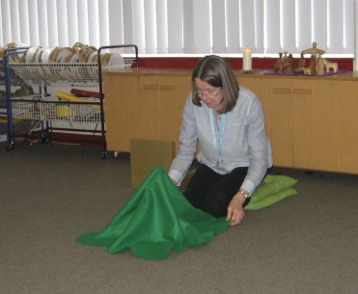
After dinner, Mrs Robertson arrived and was warmly welcomed by the children. There were a multitude of volunteers eager and willing to help to set up the cushions, the Worship table and the ‘feast’. When everything was ready, the children lined up calmly and quietly to enter the special space that had been created. They were welcomed into the room and the children sensibly sat on the cushion that they were assigned. They were delighted to share their personal cushions with each other.
Mrs Robertson shared the story of ‘The Lost Sheep’ with the children. You could have heard a pin drop. The teachers had never seen the children so calm, quiet and focussed! At one point in the story, Mrs Robertson placed one of the wooden sheep figurines under a dark piece of material which signified danger. The fear on the children’s faces was evidence of the feelings that were provoked.
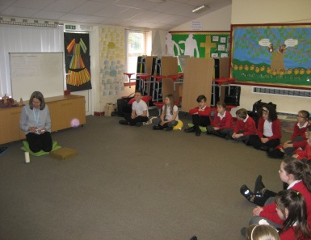
After the story, it was time to discuss the children’s ‘wonderings’. The children had been so captivated and involved in listening to the story they had lots of thoughts, feelings and questions that they wanted to share with the class or reflect on in quiet contemplation. One child said that he felt really warm and it felt like the Holy Spirit had tapped him on the head. Another said that he felt relaxed because the atmosphere was peaceful and ‘comfy’ and that Mrs Robertson told a great story. He exclaimed that he was going to go home and tell his family a Godly Play story; which he did that night.
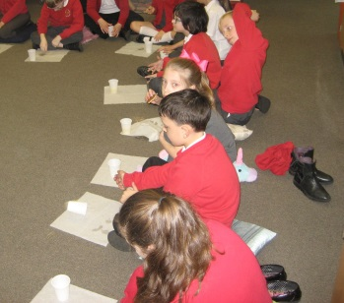
And then it was time for the ‘feast’. What a lovely way to finish such a special activity, sharing food and drink together. It also gave the children time to chat about their experiences in a more informal way. Some of the children talked about feeling peaceful and close to God and Jesus. The topics of trust, leadership and being a good person like the Good Shepherd were also discussed.
Godly Play is such an excellent experience in which the children learn, reflect, share and above all love to take part in. The staff and children at The Whitley would like to thank Mrs Robertson for volunteering to come to school and skilfully lead these sessions.
The school is really fortunate because Mrs Robertson is visiting The Whitley again, in May, to share the story of "The Circle of the Church Year", a liturgical action story, and the staff and children can’t wait.
Claire Bruce
Class Teacher -Whitley Memorial Church of England First School

