PET THERAPY POLICY AND RISK ASSESSMENT

Date policy written | March 2020
Date policy last reviewed | May 2023
Signed | Claire Gray | Head Teacher
Signed | Chris Peart | COG

Introduction
Children can benefit educationally and emotionally, increase their understanding of responsibility and develop empathy and nurturing skills through contact with a dog. In addition to these benefits, children can take great enjoyment from interaction with a dog. There has been significant research that shows the positive emotional well-being results through interactions with dogs.
Roles and Responsibilities.
The Governing Body has a responsibility to ensure that the school has a written policy for dogs in School.
The Head teacher is responsible for implementing this policy.
Teachers, staff, pupils, parents and visitors are required to abide by this policy.
The curriculum will support learning about dogs and how best to behave around our dog. This will include highlighting that not all dogs are well trained and that caution must be used around unknown dogs outside school.
Reasons to have a dog in school
In summary, academic research has shown that dogs working and helping in the school environment can achieve the following:-
- Improve academic achievement
- Increase literacy skills
- Calming behaviours
- Increase social skills and self-esteem 5) Increase confidence
- Teach responsibility and respect to all life
- Help prevent truancy
- Motivate children who are often less attentive
The following information has been taken from a range of sources to provide further detail about the benefits of having a dog in school:
Behaviour:
In some schools, dogs are making a difference in the behaviour of pupils. Researchers report that students can identify with animals, and with empathy for the dog, can better understand how classmates may feel. It was found that violent behaviour in participating students declined by 55%, and general aggression went down 62%. Behaviour problems occur in school and these can interfere with learning. Some schools are using dogs to improve behaviour problems by promoting positive behaviour in students. In a controlled study, students were found to have fewer disciplinary referrals in schools with a dog than schools without. Students’ behaviour improved toward teachers and students also showed more confidence and responsibility. Additionally, parents reported that children seemed more interested in school as a result of having a dog at school.

Attendance:
Case study: Mandy was a student with poor attendance and truancy. Mandy was encouraged back into school using caring for River, a dog, as an incentive. By telling Mandy that “if he didn’t come to school to care for him, River would miss her and not get as much love,” Mandy came to school almost every day for the rest of the year, only missing two days.
Education:
Reading programmes with dogs are doing wonders for some students. Children who might be embarrassed to read aloud to the class or even adults are likely to be less scared to read to a dog. “It might be less stressful for a child to read aloud to a dog than to a teacher or a peer. After all, a dog won’t judge or correct you.” Dogs are used to encourage struggling readers to practise reading aloud. With the presence of a “calm and well-trained dog,” students find social support and peer interaction.
Dogs can be incredibly calm and happy to have student read to them or join a group of children in the library whilst they are having a book reading session. Dogs give unconditional acceptance, as they are non-judgmental, which is especially crucial to struggling, emerging readers. Dogs can also provide confidence to children as they do not make fun of them when they read, but above all they make amazing listeners, providing the children with a sense of comfort and love. Research has proved that students who read to dogs show an increase in reading levels, word recognition, a higher desire to read and write, and an increase in intra and interpersonal skills among the students they mix with.
Social Development:
Dogs in school offer an opportunity for improving social development. They are especially useful for teaching students social skills and responsibility. Specifically, schools are using dogs to help older students build self-esteem; learn about positive and negative reinforcement, responsibility, and boundaries. Students can use dogs to help with communication and learn about responsibility and kindness.
With a dog in school, students have the opportunity to learn how to care for the animal. This includes walking and grooming. Researchers report that involving students in the daily care of classroom dogs is a positive experience, promoting their own daily care. The students also learn about responsibility, caring and sharing when helping each other take care of a dog at school.
As a reward:
Dogs can be gentle and loving, but at the same time full of fun and enjoyment for the students. Students can be rewarded with spending time during lunch or break to interact with the dog. Walking, grooming, playing and training are some of the responsibilities students will be allowed to undertake. It has been proved that working and playing with a dog improves children’s social skills and self-esteem.
Dogs can work with students on a one-one basis and can especially help those students who have been bullied, abused, are going through upsetting/difficult times or are even scared/phobic of dogs. The dog will bring much joy and help to all the students they meet and are happy to provide plenty of hugs to the students they are spending time with. Students who struggle with social interaction can find a reassuring friend in a dog.
Is there a risk in bringing a dog into a school environment?
Yes there is however if the dog is managed correctly there should be no greater risk that other everyday situations that the children encounter. Therefore, it is just another risk that needs to be managed. A thorough risk assessment has been carried out and this is included in this document (see appendix 1).
No dog is allowed anywhere on the school site at any time unless specifically authorised by the Headteacher. This includes drop off and collection times. This policy outlines measures put in place to allow Bailey to be present.
Policy and Procedures
The school dog (Bailey) is owned by Mrs Whiting
- The Governing Body have the right to refuse entry to any dog including Bailey.
- Only Bailey is allowed on the school premises. All other dogs must not come on site unless they are a known therapy or assistance dog and the Headteacher has been informed. Permission from the Headteacher must be sought and obtained for any other dog to come onto the school site.
- Bailey is a Red Setter, a breed chosen because of its intelligence, trainability and good temperament . It is also a breed that is very good with children.
- The Governing Body agree that having Bailey in school will benefit the children and staff of Whitley Primary School.
- Staff, parents and children have been informed that a dog will be in school and have had the time to comment upon the idea. A full risk assessment has been produced and this will be reviewed on a regular basis.
- Children, staff and visitors known to be allergic to Bailey will not go near him and all visitors will be informed that there is a dog in school.
- If Bailey is ill he will not be allowed in school.
- Bailey will be kept on a lead when moving around the school site and will be under the full control and supervision of a designated handler or responsible adult.
- Children will never be left alone with Bailey and there must be appropriate adult supervision at all times.
- Children will receive instruction (with regular reminders) about appropriate behaviour around dogs including the need to stay calm and not make sudden movements or make loud noises
See appendix 2 for rules related to Bailey.
- Children will be taught about dog body language and what to do in certain situations.
- Children will be taught to always wash their hands after touching Bailey.
- Any dog poo will be cleaned up immediately and disposed of appropriately. Bailey will be trained to use the grass area out at the front of the office (an area not accessed by the children) as a toileting place.
- Records will be kept about Bailey’s interaction with children and anecdotal evidence of his impact in school.
- The office or Mrs Gray will know the whereabouts of Bailey at all times.
- In case of evacuation (fire etc) Bailey will be taken from the building by the responsible adult who he is with at the time of the alarm.
Actions
If someone reports having an issue with Bailey, this information must be passed to Mrs Gray as soon as possible. All concerns will be dealt with as soon as possible, appropriate action taken and the risk assessments reviewed.

Appendix 1 – Risk Assessment
Whitley Primary School Risk Assessment School Dog - Bailey
Introduction:
The value of school dog is widely accepted as a powerful aid to stimulation and communication. Studies have shown that the presence of companion animals can improve the well-being of children and lower the rate of anxiety, simply by making the environment happier, more enjoyable and less forbidding.
The rationale behind the decision to introduce a school dog was as follows:
- For the school to have a pet that was able to live as naturally as conditions would allow. ● For the animal to be properly cared for outside of the school day.
- To have a pet that the children could interact with and also be of benefit to the children’s social and emotional development.
It is accepted that interacting with animals is not appropriate for all children but for some it has the potential to provide many positive benefits. Any parent who does not want their child to interact with the dog is invited to write to Mrs Gray and inform her of their wishes. There are no diseases associated with the dog as her vet will be responsible for vaccinations, completing regular health checks and necessary treatment. A copy of the dog’s health records will be updated and will be available upon request. The dog will also be insured.
The risk assessment below is a working document and will be checked regularly by key staff.
Hazard | Risk | Risk  1-5 | Controls in Place
Bailey getting over excited when interacting with children | Child getting knocked to the ground (Bailey jumping up).  Child scratched by Bailey  Child bitten by Bailey (even if unintended) | 2  3  4 | Bailey will always be in the care of a designated handler or a responsible adult. A responsible adult means any member of staff who has read the policy fully, received appropriate training and is aware of the risks and responsibilities to both children and staff.  When not ‘working’ Bailey will be kept in a pen (or out of pen with door shut) in either the Headteacher’s office or the meeting room.  Bailey will never be allowed to roam freely around the school premises.  Children will never be left unsupervised with Bailey.

Bailey will always be on a lead when moving around the school (both inside and outside)
Pupils will be taught how to behave around dogs, how to interact with Bailey and what a dog’s body language says about how they are feeling. This will be reinforced on a regular basis.
Children will be taught how to react if Bailey does get over excited.
All staff will read this risk assessment and the policy and be aware of expectations of staff and children with regards to Bailey.
Bailey will undergo formal training with experienced and accredited trainers. This training will be reinforced at all times. As training progresses and Bailey.
Bailey will undergo formal training with experienced and accredited trainers. This training will be reinforced at all times. As training progresses and Bailey becomes more accustomed to school life these risks will lower considerably. Bailey will visit the vet regularly to ensure he is in good health (if he is not he will not be brought to school) and that his claws are kept short.

Bailey may cause allergies | Children or staff have an allergic reaction | 1 | Bailey is a Red Setter and he is groomed regularly. School is kept clean with carpets vacuumed regularly.  Parents are able to request that their child/children do not interact with Bailey if there are known allergies. We should already be aware of such allergies through our data collection procedures. A list of any children/staff who should not interact with Bailey will be kept in school and updated as required.  Children will be taught to wash their hands after interacting with Bailey.
Children or adults getting germs from Bailey. | Children or adults contracting diseases or illness that can be carried by dogs. | 1 | Should Bailey defecate on the school site it will be cleaned up immediately (by an adult) and disposed of appropriately.  Bailey will be trained to toilet in an area of the grounds (front garden outside offices) that children have limited access to. This area will be disinfected regularly.
All immunisations are kept up to date in
accordance with the European Pet Passport Scheme and a record of this will be kept.
Flea and worm treatment will be carried out regularly and recorded.
Bailey will not be allowed in the school hall at meal times and never in the school kitchen.

Noise and barking | Some children may be sensitive to the noise | 1 | Bailey is being introduced to school life slowly so he will be used to the environment meaning he is less likely to bark.  If required, specific children can have extra or fewer sessions with Bailey.  If required specific and identified children would be allowed to use ear defenders.

Key:
- – Low risk
- – Low to medium risk
- – Medium risk
- – Medium to high risk
- – High risk

Appendix 2
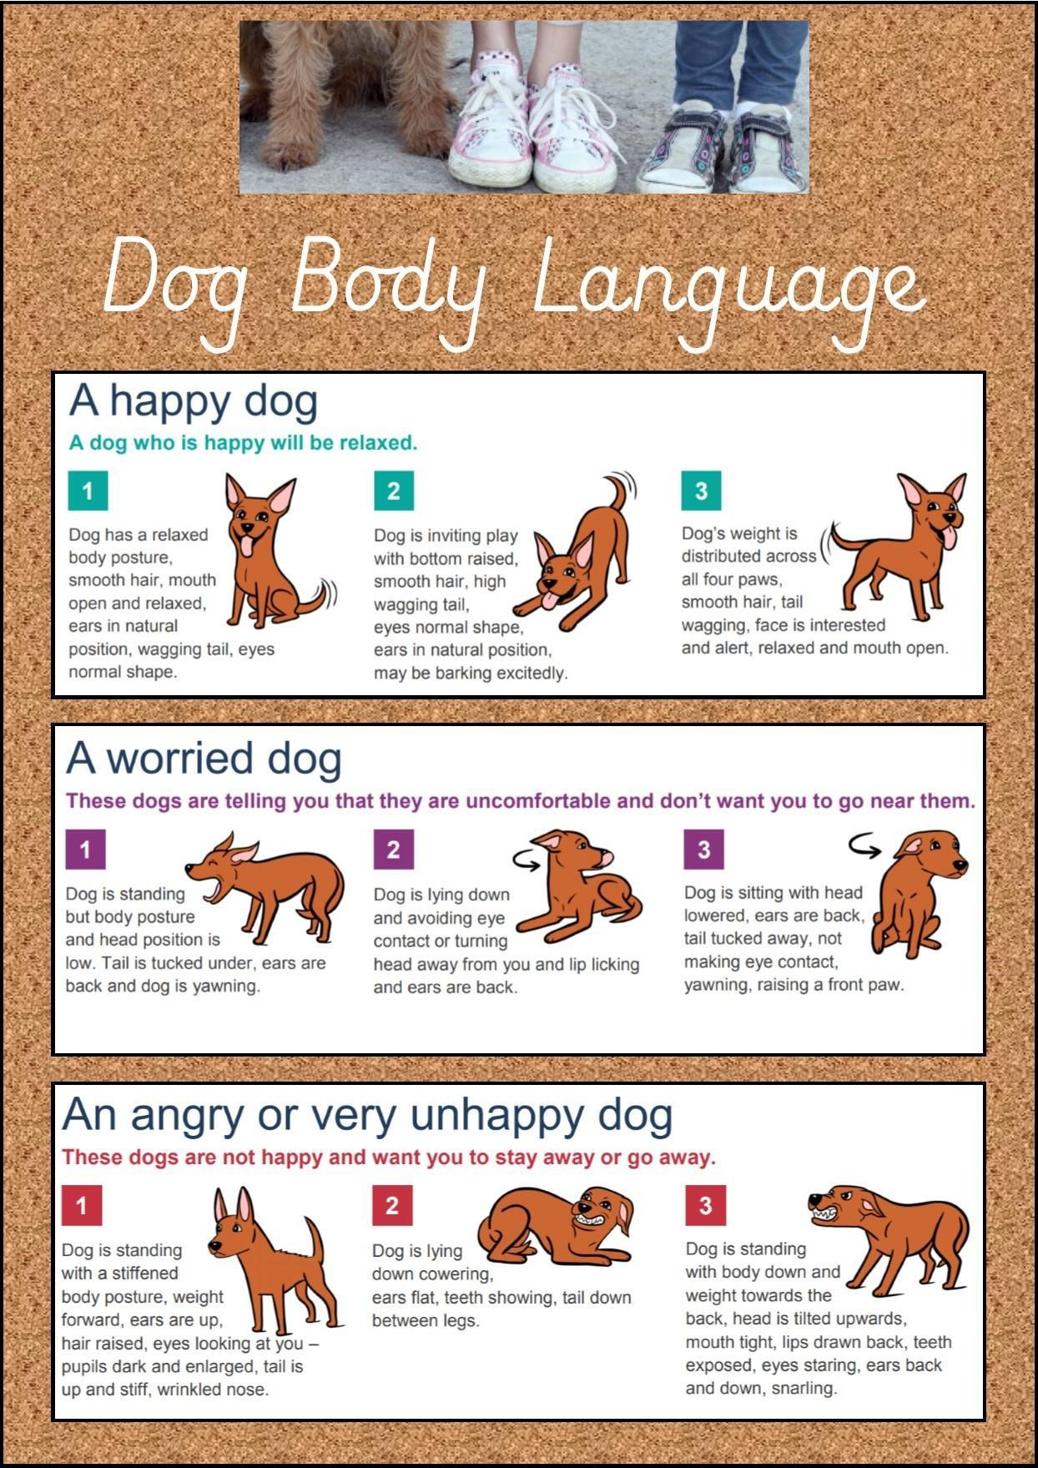

Appendix 3 – Golden Rules for Bailey

Golden Rules for Bailey Whitley Primary School

- Always remain calm around Bailey and do not make sudden movements or loud noises.

- Always approach Bailey standing up so he can see you coming.

- Wait for Bailey lying down before you touch or stroke him.

- Do not approach Bailey if he is asleep, eating, looks scared or if he is already busy.

- Always stroke Bailey’s back. Do not stroke his head or near his mouth.

- Never put your face near Bailey’s mouth or stare in to his eyes.

- Only 3 children to be around Bailey at each time.

- Never play rough with Bailey.

Appendix 4 – FAQS
Appendix 4 - Bailey FAQs
Q. Who is the legal owner of Bailey and who pays for her costs?
A. The legal owner of Bailey is Mrs Whiting; she will bear the costs associated with owning her; the school budget will support insurance and staff training costs where appropriate. Q. Is Bailey from a reputable breeder?
A. Yes. Bailey is from a home where both parents were seen and has been specifically chosen for his temperament.
Q. Will Bailey be a distraction?
A. Bailey will be kept in the office area. This will ensure he only comes into contact with children who are happy to have contact and only at appropriate times meaning children should not be distracted. Parents can request that their child does not have contact with Bailey by either writing to or emailing the school office. Q. Has a risk assessment been undertaken?
A. Yes, we have carefully considered having a dog in school and sought advice from many sources, including other schools that successfully have a school dog. Q. Who is responsible for training?
A. Mrs Whiting will be the legal owner of Bailey and as a result, will be responsible for her training. Appropriate professional training will also be obtained.
Q. How will Bailey be toileted to ensure hygiene for all?
A. In the interest of health and hygiene Bailey will be toileted when taken out for short walks in the grounds. He will be trained (as far as possible) to toilet on the grass area outside the office. This area is not accessed by the children. Only staff members will clear this away appropriately leaving no trace on the ground, cleaning the area with disinfectant if needed. Q. Are other dogs allowed on the school site?
A. Our policy of no dogs in the playground is still applicable as we are unable to put effective control measures in place that guarantee temperament and safety when children come into unsupervised contact with unknown dogs. Permission needs to be obtained from the Headteacher for any other dog to be on the school site. This permission will always be granted for suitably trained assistance dogs.
Q. How will Bailey’s welfare be considered?
A. Bailey will be walked regularly and given free time outside. Bailey will be kept in the office area and will only have planned and supervised contact with children and visitors. Bailey will be carefully trained over a period of time and will have unlimited access to fresh water as well as appropriate access to food. We will work carefully to ensure the Bailey’s welfare is always considered and if Bailey is distressed or unhappy his use in school will be re considered.
Q. How will this be managed where children have allergies?
A. Children will not need to touch Bailey, which will relieve the possibility of allergic reactions. We already manage a number of allergies at school and this will be no different for children and adults that are allergic to dogs. Individual needs will always be met and we are happy to work with parents to put additional control measures in place for individual allergies. Bailey is given a high quality food and is regularly groomed to reduce any possibility of allergens.
Q. My child is frightened of dogs; how will you manage this?
A. Access to Bailey is carefully managed and supervised and children do not need to have close contact with him. We hope to work closely with parents of children who are fearful of dogs to alleviate their fear and to teach them how to manage this.
If anyone has any further questions then please do not hesitate to ask. This FAQ will be updated in light of any regularly asked questions.

